1. **Nykaa:**

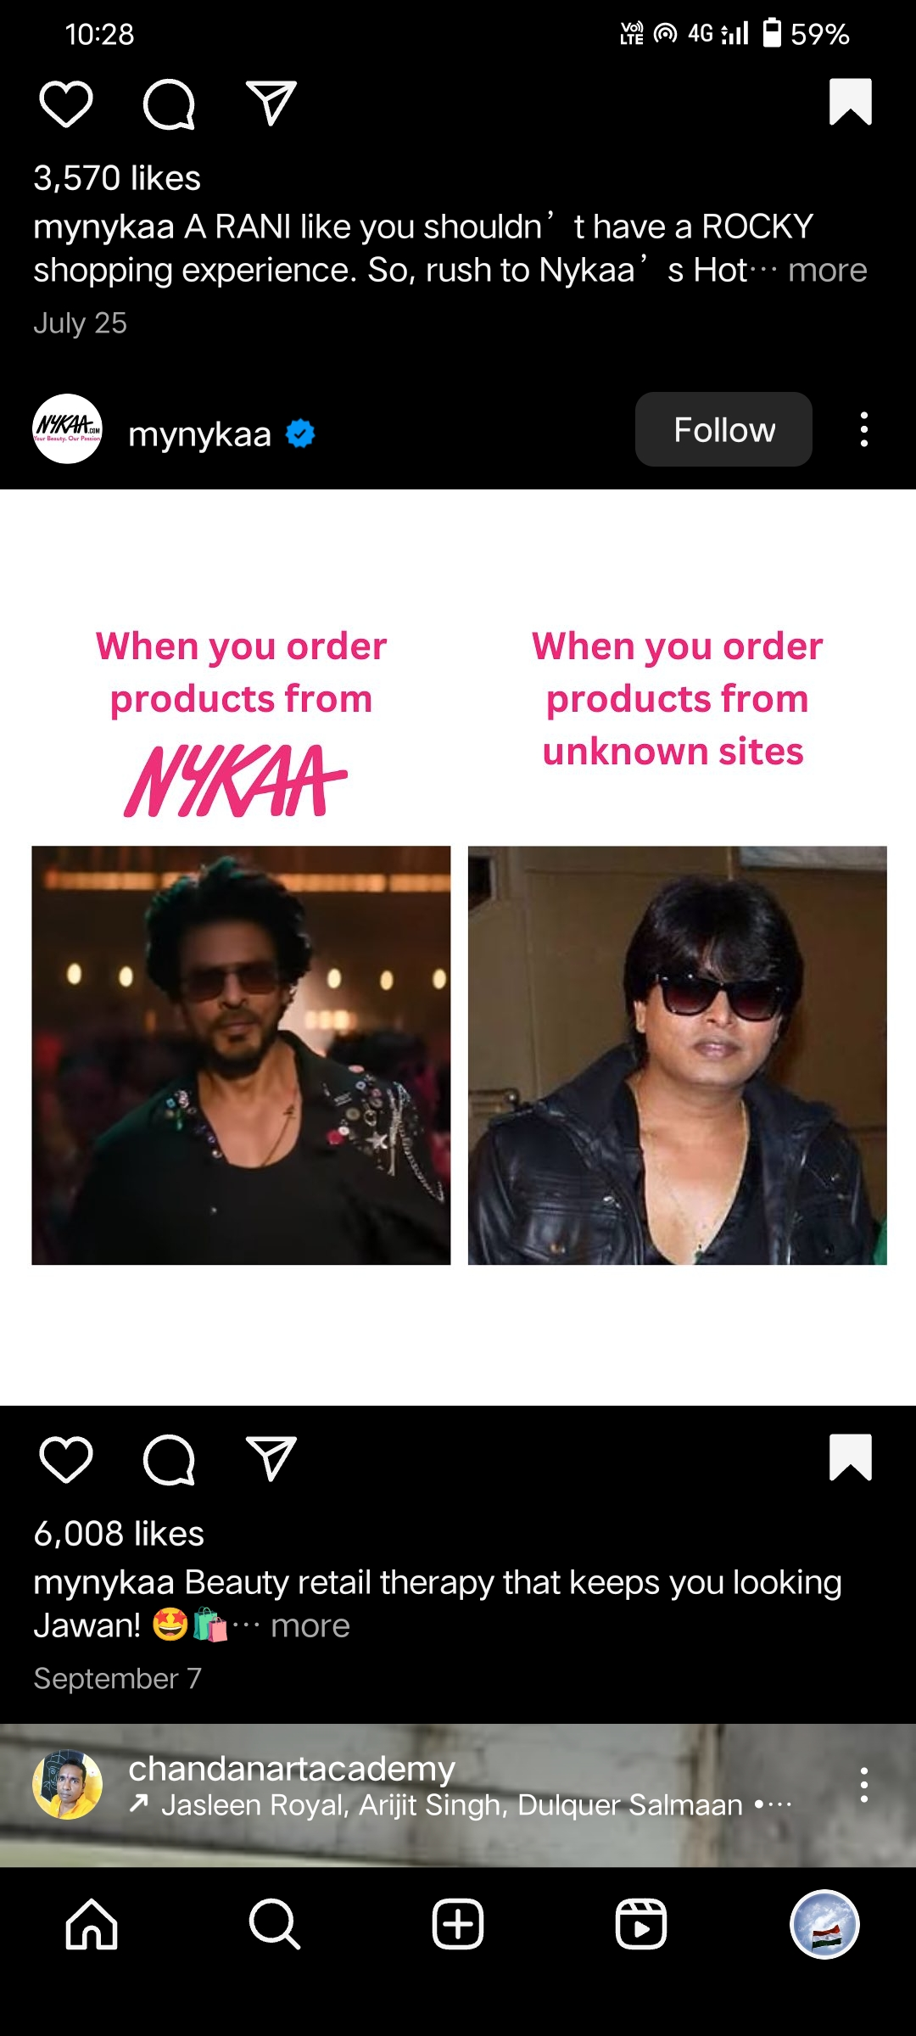

Nykaa collaborated with Bollywood hero Sharuk Khan to promote their products on their platform. So that the customers get attracted by seeing the celebrities. So they come forward to buy the product. Here who buys the product from Nykaa they looks like the celebrity, who uses other product from other sites they doesn’t look like the celebrity. Plus , it also adds a fun element making it an engaging meme post.

1. **Nykaa:**

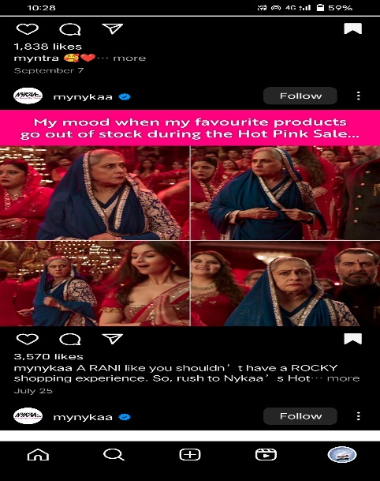

Nykaa collaborated with Disney Plus Hotstar to promote a list of popular Bollywood movies on their platform while also adding some elements of mood about the Hot pink sale in the Nykaa. Plus, it also adds a fun element making it an engaging meme post. Nykaa is a well known brand.

1. **Flipkart:**

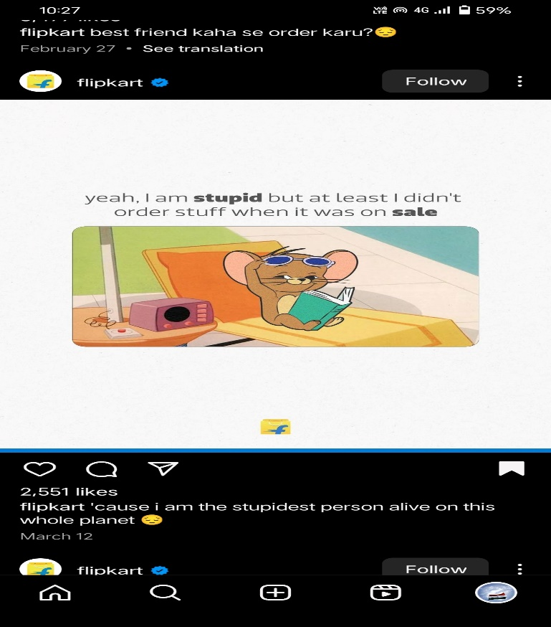

Flipkart collaborated with Cartoon Network to promote a list of popular cartoons on their platform while also adding about the sale to the poster which makes it relevant to Flipkart as a brand as well. It tells about the sale where the prices will be low. Plus, it also adds a fun element making it an engaging meme post.

1. **Myntra:**

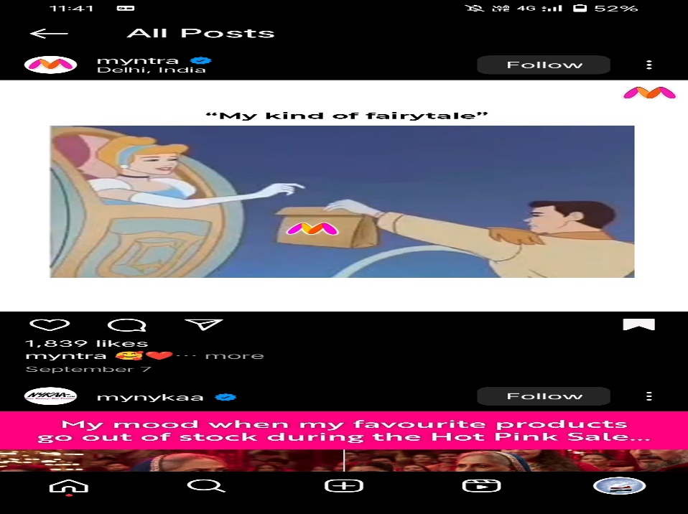

Myntra collaborated with Disney Plus to promote a list of cartoon on their platform while also adding some delivery elements to the poster which makes it relevant to Myntra as a brand as well. Plus, it also adds a fun element making it an engaging meme post.

1. **Swiggy:**

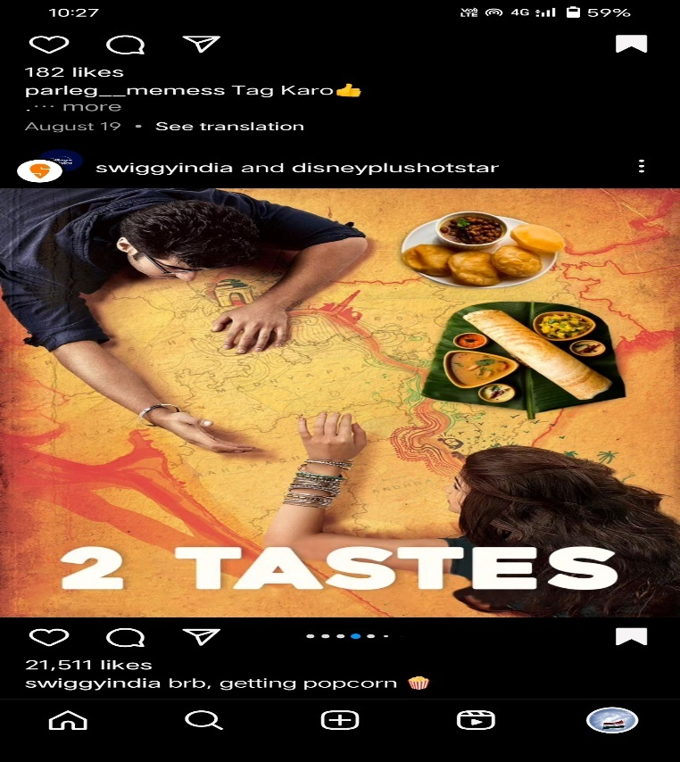  
Swiggy collaborated with Disney Plus Hotstar to promote a list of popular Bollyhood movies on their platform while also adding some food elements to the poster which makes it relevant to Swiggy as a brand as well. Plus, it also adds some funny element that engage meme post.